# 

# 

# 

# Asteroids

TBD

Design Model

Table of Contents

**Asteroids** **1**

**1. Static View: Class Diagrams** **3**

Figure 1.1: Game Class Diagram 3

Figure 1.2: Store Class Diagram 4

Figure 1.3: Net Class Diagram 5

Figure 1.4: Server Class Diagram 6

Figure 1.5: UI Class Diagram 7

Figure 1.6: Technical Services Class Diagram 8

**2. Dynamic View: Software Sequence Diagrams** **9**

Figure 2.1: Play Game SSD 9

Figure 2.2: Purchase Power Up SSD 10

Figure 2.3: Maintenance SSD 11

Figure 2.4: Brag on Social Media SSD 12

**Revision History**

|  |  |  |  |
| --- | --- | --- | --- |
| **Version** | **Date** | **Description** | **Author** |
| Elaboration Draft | 10/31/2018 | First Draft. | Eric Guzman |
| Elaboration 2 | 12/11/2018 | Fixed Game Class has long rock now, and added 4th fully dressed uc. Replaced Play Game SSD with updated diagram. | All |

# **1. Static View: Class Diagrams**

The next diagrams represent the static view of our design model.

## **Figure 1.1: Game Class Diagram**

This model shows the classes that are related to store side of project. The Ul side of the project creates the factory and the factory creates gameFactory from there store factory creates the rest of the classes that the UI can use.

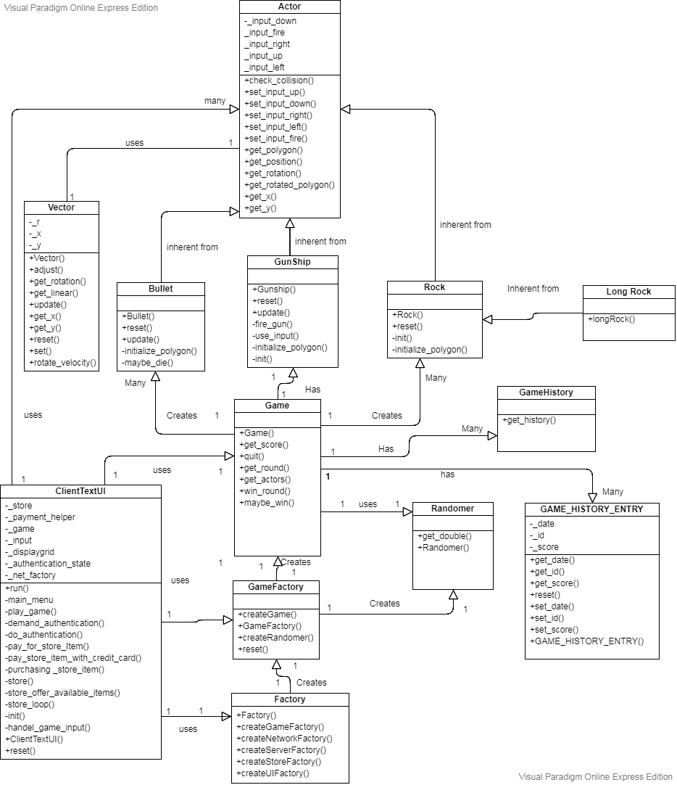

## **Figure 1.2: Store Class Diagram**

This model shows the classes that are related to store side of project. The Ul side of the project creates the factory and the factory creates storeFactory from there store factory creates the rest of the classes that the UI can use.

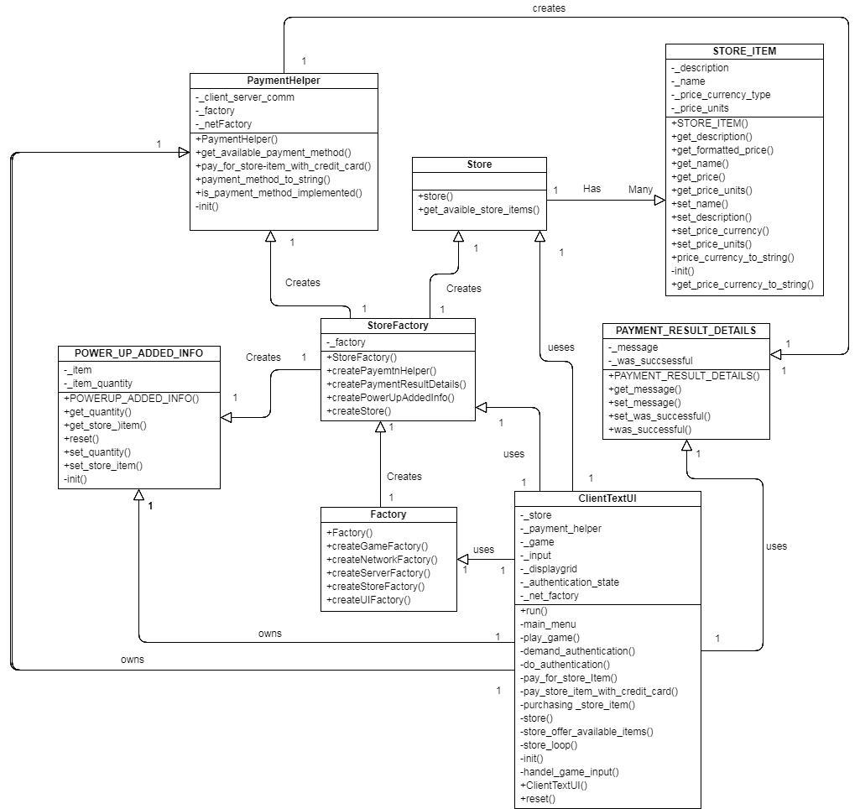

## **Figure 1.3: Net Class Diagram**

This model shows the classes that are related to store side of project. The Ul side of the project creates the factory and the factory creates netFactory from there store factory creates the rest of the classes that the UI can use.

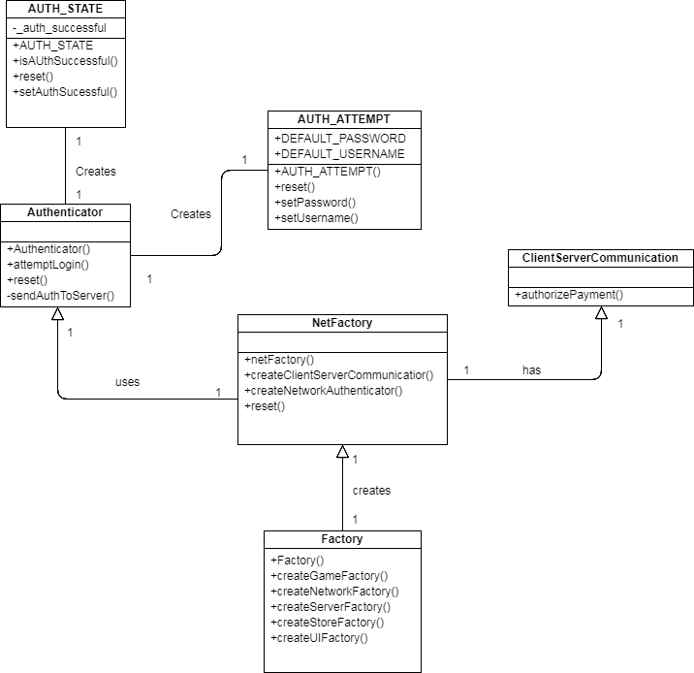

## **Figure 1.4: Server Class Diagram**

This model shows the classes that are related to store side of project. The Ul side of the project creates the factory and the factory creates ServerFactory from there store factory creates the rest of the classes that the UI can use.

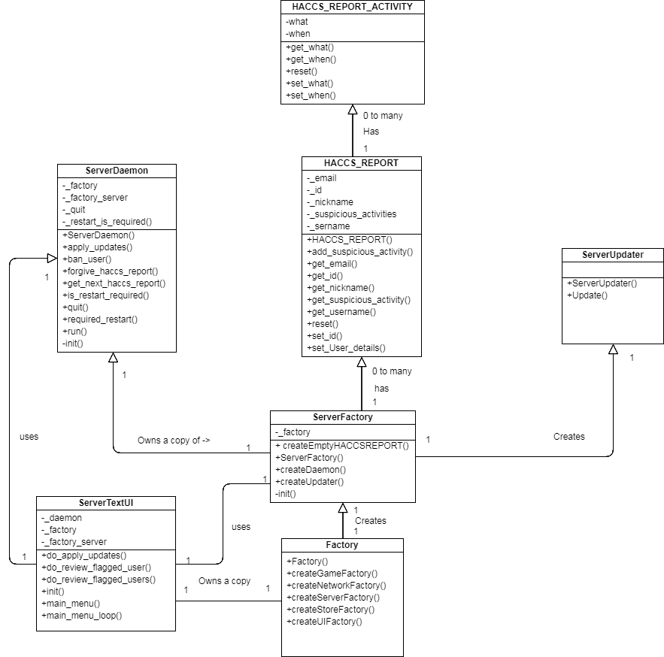

## **Figure 1.5: UI Class Diagram**

This diagram shows the UI side of the project.

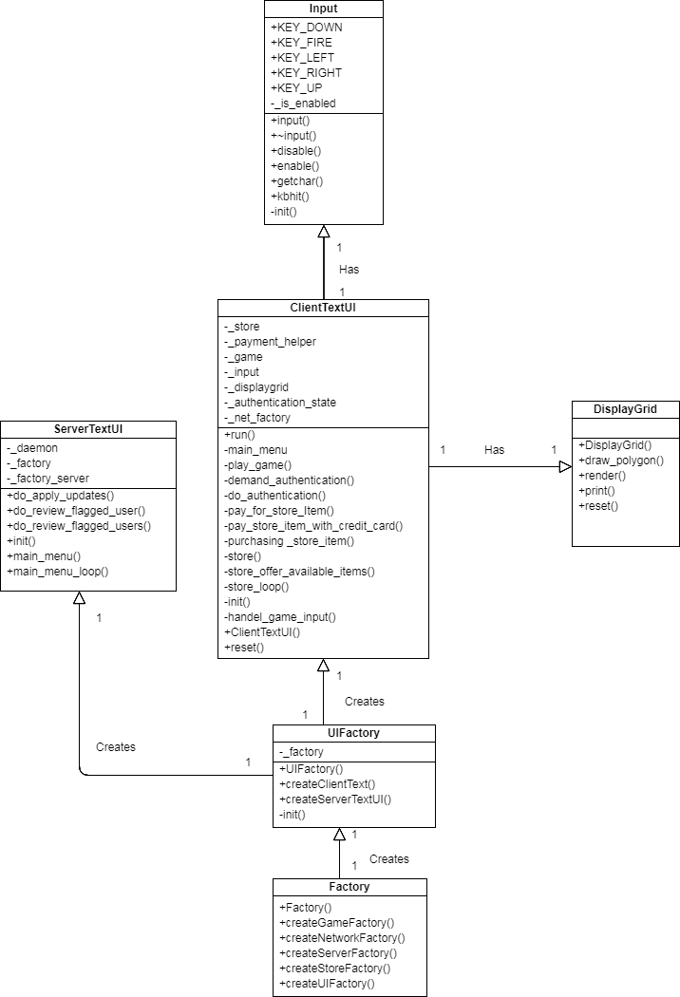

## **Figure 1.6: Technical Services Class Diagram**

This diagram shows the Technical Services side of the project.

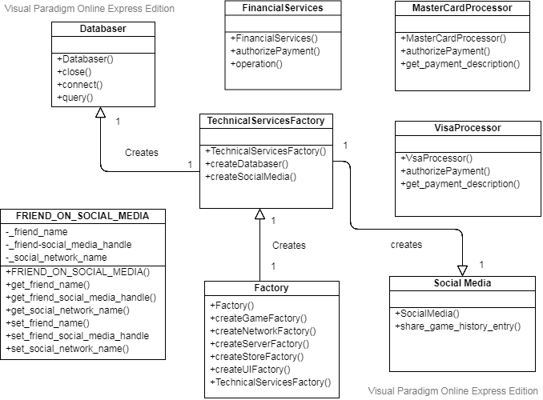

# **2. Dynamic View: Software Sequence Diagrams**

The next diagrams represent the Dynamic view of our design model. They closely resemble the system sequence diagrams that can be found in our Use case Model.

## 

## **Figure 2.1: Play Game SSD**

This software sequence diagram shows how functions are passed throughout the classes in the system. We have split this SSD into two parts for easier viewing. (You’re welcome).

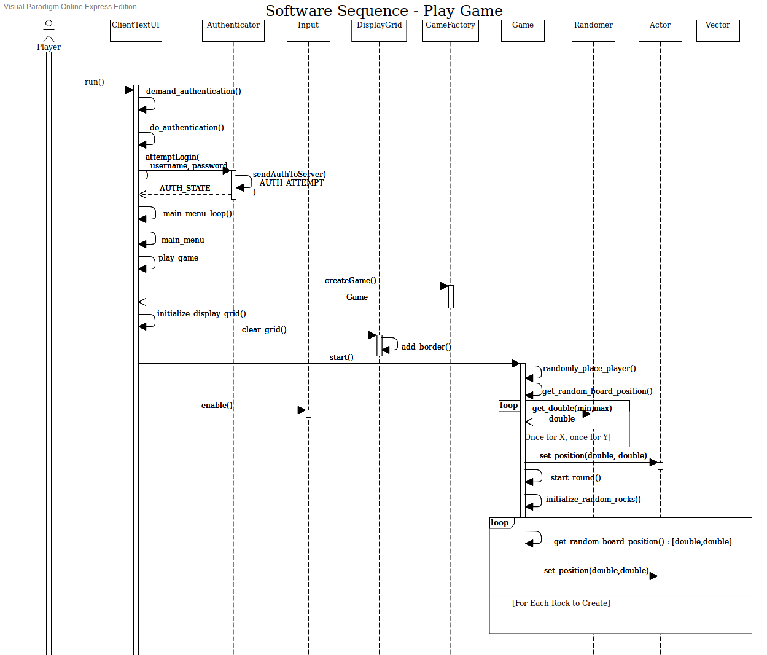

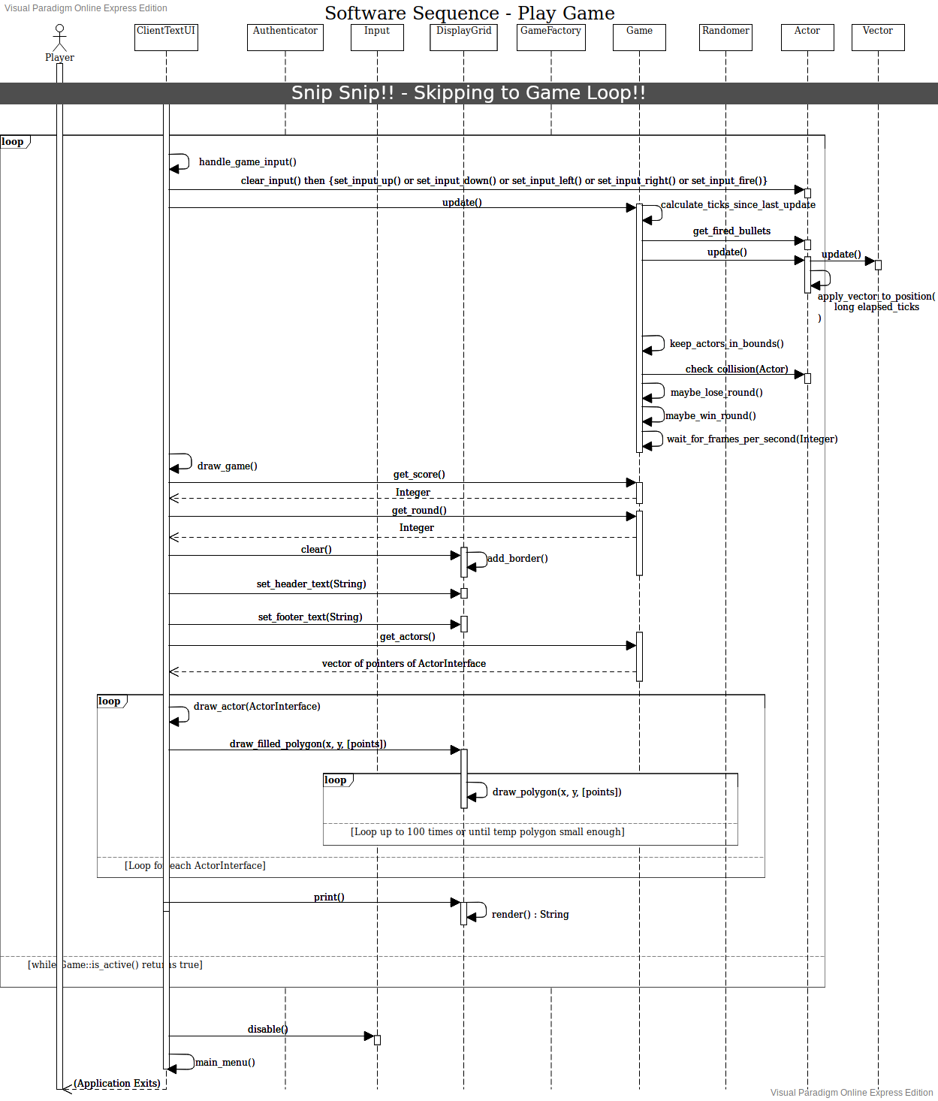

## 

## **Figure 2.2: Purchase Power Up SSD**

This software sequence diagram shows how functions are passed throughout the classes in the system

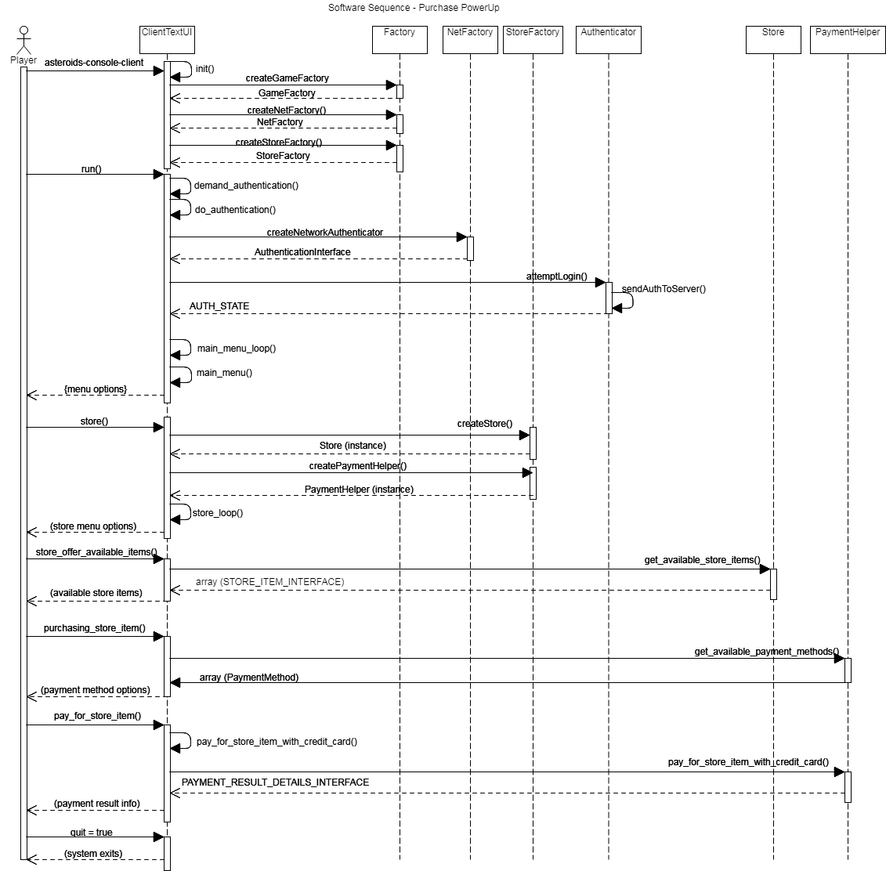

## **Figure 2.3: Maintenance SSD**

This software sequence diagram shows how functions are passed throughout the classes in the system

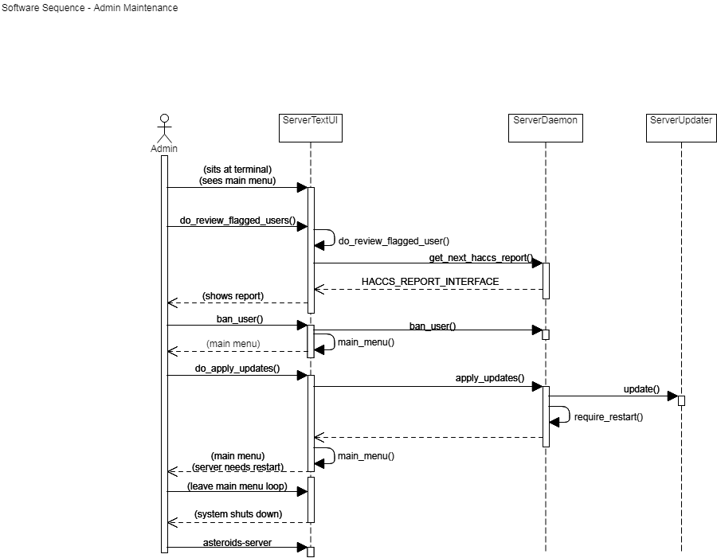

## **Figure 2.4: Brag on Social Media SSD**

This software sequence diagram shows how functions are passed throughout the classes in the system.

